***Fusarium* Genome Assemblies Report**

# Raw Read Mapping

The raw Illumina paired-end reads for the *Fusarium* isolates S6, S16, and S32, which are reported to be highly virulent on banana, were supplied by collaborators at Tamil Nadu Agricultural University, India (TNAU). Following FastQC analysis, raw reads were mapped to *F. oxysporum* f. sp. *cubense* Tropical Race 4 (Warmington, *et al*., 2019) reference quality genome using BOWTIE2, however, there was only an 8.72%, 53.81%, and a 15.69% alignment for raw reads, respectively.

Due to the low alignment rates, unmapped reads were extracted and a random subset of ~1000 reads per isolate were search using NCBI web BLAST. For isolates S6 and S32, the majority of hits with >90% coverage and identity were for *Stenotrophomonas* species, particularly *Stenotrophomonas maltophilia*. Further, the raw S6 and S32 reads show a similar GC% to the *S. maltophilia* reference genome assembly ([GCA_900475405.1](https://www.ncbi.nlm.nih.gov/data-hub/genome/GCF_900475405.1/)) (S6=63%, S32=61%, *S. maltophilia* reference=66.5%). For isolate S16, the majority of hits for unmapped reads with >90% coverage and identity against the NCBI database were for *Fusarium fujikuroi.* As an isolate previously supplied by TNAU (SY-2), which appears to be a *F. sacchari* isolate, showed a similar mapping rate to *F. oxysporum* f. sp. *cubense,* andhad hits for *F. fujikuroi* when raw reads were BLAST searched against the NCBI database, we mapped the raw S6, S16, and S32 reads to the *F. sacchari* reference FS66 ([GCA_017165645.1](https://www.ncbi.nlm.nih.gov/data-hub/genome/GCA_017165645.1/)). Isolates S6, S16 and S32 were also mapped to a reference quality *Stenotrophomonas maltophilia* genome.

Approximately 50% of raw reads from isolates S6 and S32 mapped to the *S. maltophilia* reference (Table 1). Isolate S16 raw reads only had a 0.01% mapping rate to the *S. maltophilia* reference. Isolates S6 and S32 had a 5.24% and 22.49% mapping rate to the *F. sacchari* reference, respectively, whereas 68.65% of the raw reads from isolate S16 mapped to the *F. sacchari* reference.

**Table 1: Overall alignment rate of all raw reads from each TNAU isolate to fungal and bacterial reference species**. Overall alignment rate determined by Bowtie2 (version 2.4.5).

|  |  |  |  |  |  |  |  |
| --- | --- | --- | --- | --- | --- | --- | --- |
| **Reference Species** | **Isolate Bowtie2 Raw Read Overall Alignment Rate** | | | **Reference Strain** | **Reference GenBank Accession** | **No. of Contigs** | **Contig N50 (Mb)** |
| **S6** | **S16** | **S32** |
| *F. oxysporum f. sp. cubense (TR4)* | 8.72% | 53.81% | 15.69% | UK0001 | GCA_007994515.1 | 15 | 4.49 |
| *F. sacchari* | 5.24% | 68.65% | 22.49% | FS66 | GCA_017165645.1 | 48 | 1.97 |
| *Stenotrophomonas maltophilia* | 49.32% | 0.01% | 53.93% | NCTC10258 | GCA_900475405.1 | 1 | 4.5 |

# *De novo* Genome Assembly and BlobTools Analysis

As the S16 isolate raw reads had a low mapping rate to the *S. maltophilia* reference, and BLAST searches of unmapped reads showed a high number of hits for *Fusarium* species, we generated a *de novo* assembly for the S16 isolate using all raw reads with SPAdes (v3.14.1). SPAdes is routinely employed in the generation of *Fusarium* genomes (see: Armitage, *et al.,* 2018; Hudson *et al.,* 2020, Tanaka, *et al.,* 2022), and was used to generate the SY-2 assembly assembly (report shared in June 2022). Quast (v5.0.2) (Gurevich, *et al.,* 2013) and QualiMap (v.2.2.2-dev) (Okonechnikov, *et al.,* 2016) was used to estimate assembly quality.

The initial *de novo* SPAdes assembly for isolate S16 showed a high number of contigs which had <25% GC content. A custom python script was therefore used to remove sequences with <25% GC content from the assembly, as was performed for the SY-2. The subsequent trimmed assembly contained 417 contigs. For benchmarking universal single-copy orthologs, BUSCO (version 5.4.6) was used (Manni, *et al.,* 2021). A BUSCO completeness score of 97.4% was generated using the hypocreales_odb10 dataset. The raw S16 reads were mapped back to the S16 *de novo* SPAdes assembly and a Qualimap assessment conducted; 99.53% of the reads mapped and mean coverage was estimated to be 148x (Table 2).

**Table 2: Summary statistics of TNAU genome assemblies**. De novo assemblies generated using SPAdes (version 3.14.1) with all raw reads supplied by Tamil Nadu Agricultural University.

|  |  |  |  |
| --- | --- | --- | --- |
| **Assembly**  **Statistic** | **TNAU Isolate Assembly** | | |
| **S6** | **S16** | **S32** |
| Number of contigs | 38362 | 417 | 291 |
| Largest contig (Mb) | 0.83 | 0.88 | 1.76 |
| Total length (Mb) | 97.64 | 44.86 | 49.62 |
| GC (%) | 46.75 | 47.53 | 49.80 |
| N50 (bp) | 45916 | 234991 | 629760 |
| N75 (bp) | 1330 | 109641 | 309033 |
| L50 | 375 | 60 | 26 |
| L75 | 6423 | 130 | 54 |
| Mapped Reads | 99.35% | 99.53% | 99.87% |
| Mean Coverage | 66x | 148x | 206x |

Although the S6 and S32 isolate had high mapping rates to *S. maltophilia* reference, all raw reads were used to generate a *de novo* assembly to assess for taxonomic partitioning using BlobTools (v1.1.1) (Laetsch and Blaxter, 2017). The S6 and S32 assemblies generated using all raw reads contained 28362 and 291 contigs, had a BUSCO completeness score of 97.7% and 97.7%, were 97.64Mb and 49.62Mb in length and had a GC% of 46.75 and 49.80, respectively (Table 2). The S6 assembly is much larger than is typical for a *Fusarium oxysporum* assembly and is highly fragmented.

Once the *de novo* assembly was generated for each isolate, a Blobtools analysis was conducted. First, each assembly was searched against the NCBI nt database using BLASTN and the raw paired end reads from each isolate were aligned to the corresponding isolate assemblies using BOWTIE2. Taxonomic hits were ranked at the species level and default BlobTools settings were used. *Fusarium fujikuroi* accounted for the majority of the NCBI TaxID hits for each contig for the S16 isolate assembly, with 434 contigs assigned to this species (Figure 1).

The *de novo* assemblies generated using all raw reads for the S6 and S32 isolates contained a large number of contigs which had either no hits or were assigned to other genera*.* For instance, the majority of contigs for the *de novo* S6 assembly had no hits (Figure 2). Some of the contigs had *Fusarium fujikuroi* and *Fusarium oxysporum* assigned*.* The remaining contigs had greatest sequence similarity to bacterialspecies. The majority of contigs from the S32 *de novo* assembly had greatest sequence similarity to *Fusarium* species, particularly *F. fujikuroi,* although some contigs were assigned to *Stenotrophomonas* species, as was observed in the BLAST search of unmapped raw reads (Figure 3).

Using the raw reads which appear to be contaminated to generate a *de novo* assembly may result in misassembled contigs which are chimeric (part target species, part non-target species). These contigs can be challenging to identify and may result in contigs which should remain in the assembly being filtered out, and contigs which do not belong to the target species being kept in the assembly, even when using BlobTools to separate out target and non-target contigs. We therefore considered a reference-guided assembly approach, however, as isolates S16 and S32 have a higher mapping rate to the *F. saccahri* reference and assemblies generated using all raw reads contained contigs which shared greater sequence similarity with other *Fusarium* species, but these isolates have been classified as *F. oxysporum* f. sp. *cubense* isolates by collaborators at TNAU, determining which reference species to use it challenging. Furthermore, these isolates display a highly-virulent phenotype, and a reference-guided assembly may lose any large-scale rearrangements in the genome which may play a role in this. Consequently, for isolates S6 and S32, we have decided to map to two reference genomes (*F. oxysporum* f. sp. *cubense* TR4 isolate UK0001; *F. sacchari* isolate FS66) and then create a *de novo* assemblies with the mapped reads only.

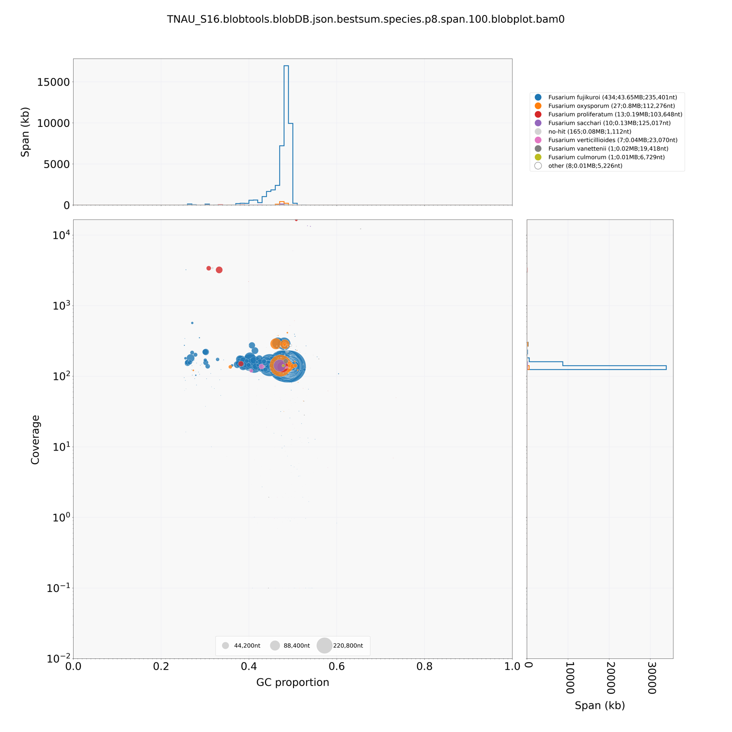

a

b

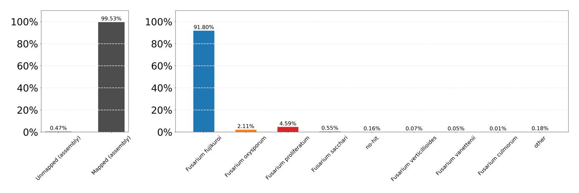

**Figure 1:** **BlobTools visualisations of S16 assembly (trimmed) shows F. fujikuroi as most common species hit.** A)BlobPlot ofS16 assembly**.** Sequences in the assembly are depicted as circles, with diameter scaled proportional to sequence length and coloured by taxonomic annotation (at the rank of species) based on BLASTN search of NCBI nt database. B) ReadCovPlot of S16 assembly. Mapped reads are shown by taxonomic group at the rank of species.

**Figure 2:** **BlobTools visualisations of S6 de novo assembly generated from all raw reads shows potential contamination of raw data.** A)BlobPlot ofS6 assembly**.** Sequences in the assembly are depicted as circles, with diameter scaled proportional to sequence length and coloured by taxonomic annotation (at the rank of species) based on BLASTN search of NCBI nt database. B) ReadCovPlot of S6 assembly. Mapped reads are shown by taxonomic group at the rank of species.

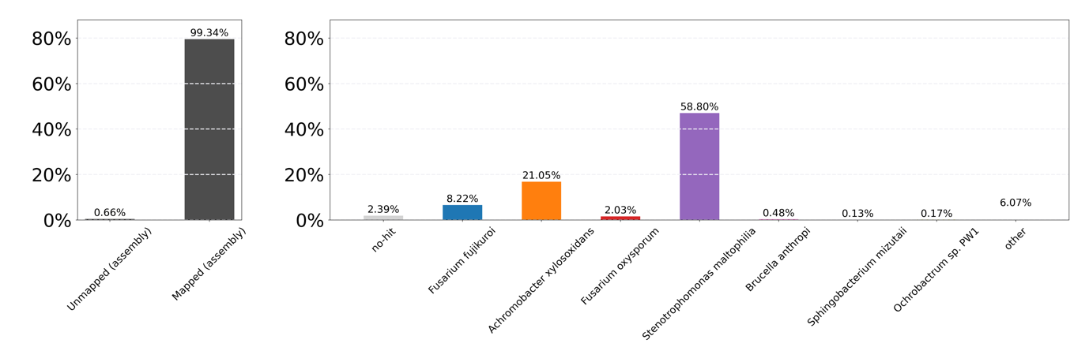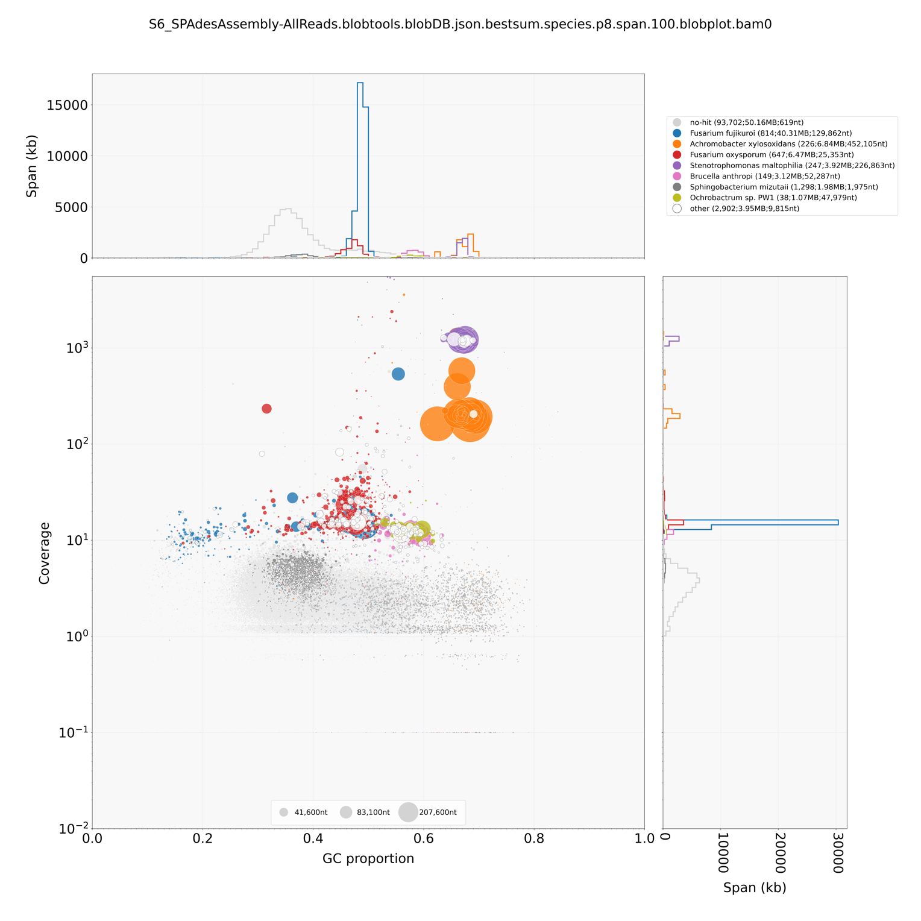

a

b

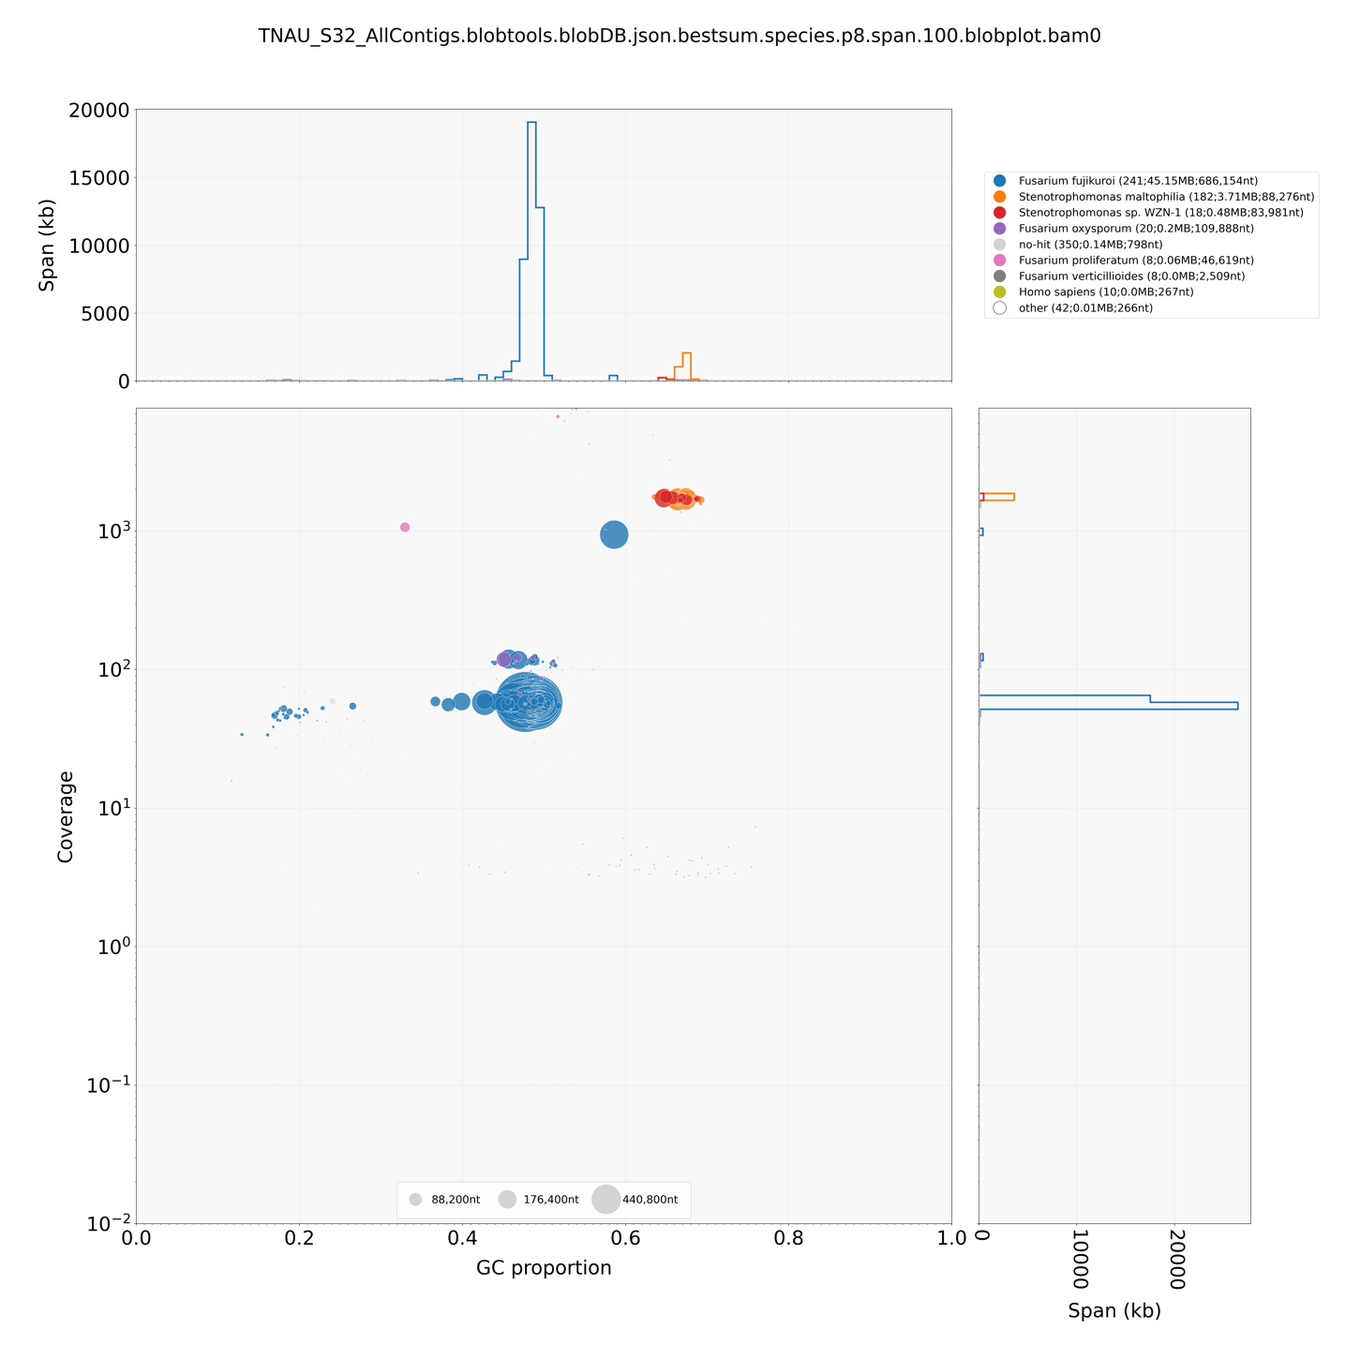

a

b

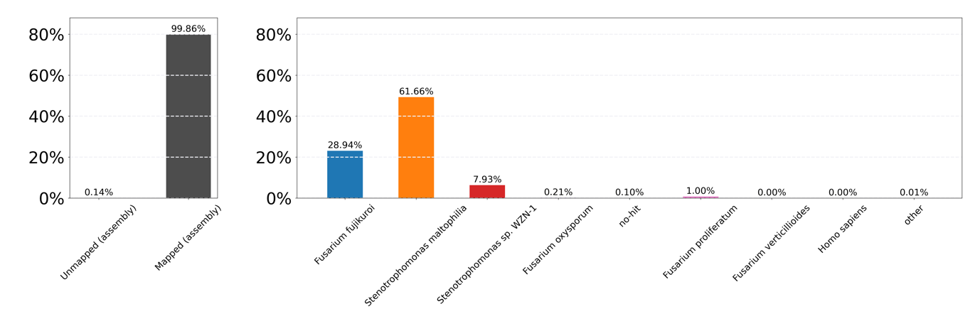

**Figure 3:** **BlobTools visualisations of S32 de novo assembly generated from all raw reads shows potential contamination of raw data.** A)BlobPlot ofS32 assembly**.** Sequences in the assembly are depicted as circles, with diameter scaled proportional to sequence length and coloured by taxonomic annotation (at the rank of species) based on BLASTN search of NCBI nt database. B) ReadCovPlot of S32 assembly. Mapped reads are shown by taxonomic group at the rank of species.

# *De novo* Assembly and BlobTools Analysis of Mapped Reads Assemblies

For each isolate (S6 and S32), two *de novo* assemblies were constructed using SPAdes (v3.14.1) from either, i) all raw reads which mapped to the *F. oxysporum* reference(isolate: UK0001, GenBank: GCA_007994515.1) or ii) all raw reads which mapped to the *F. sacchari* reference(isolate FS66, GenBank: GCA_017165645.1). Mapped reads were determined using BOWTIE2 (version 2.4.5) and were extracted in to separate FASTQ files using Samtools (version 1.6, using htslib 1.6).

Quast (v5.0.2) (Gurevich, *et al.,* 2013) was used to estimate assembly quality. The S6 *de novo* assemblies generated using the *F. oxysporum* mapped reads and the *F. sacchari* mapped reads contained 3507 and 6 contigs, were 42.86Mb and 0.02 Mb in length, and had a 48.16% GC content and 39.15% GC content, respectively (Table 3). The S6 *de novo* assembly generated using the *F. oxysporum* mapped reads had a 15.27x coverage and a BUSCO completeness score of 97.6% when the hypocreales_odb10 2020 dataset was used (Table 3, Figure 4a). As S6 *de novo* assembly generated using the *F. sacchari* mapped reads only contained 6 contigs and was 0.02 Mb in length, the BUSCO ascomycota_odb10 dataset was used, however, the BUSCO analysis still uncovered no universal single-copy orthologs, recording a BUSCO completeness score of 0.0% (Figure 4b). Due to its small size and low BUSCO completeness score, no further work has been conducted on the S6 *de novo* assembly generated using the *F. sacchari* mapped reads only.

**Table 3: Summary statistics of TNAU genome assemblies**. De novo assemblies generated using SPAdes (version 3.14.1) with raw reads which mapped to either the Fusarium oxysporum (GenBank: GCA_007994515.1) or Fusarium sacchari reference isolates (GenBank: GCA_017165645.1).

|  |  |  |  |  |
| --- | --- | --- | --- | --- |
| **Assembly**  **Statistic** | **TNAU Isolate Assembly** | | | |
| **S6** | | **S32** | |
| **Assembly Input Data** | *F. oxysporum* Mapped Reads | *F. sacchari* Mapped Reads | *F. oxysporum* Mapped Reads | *F. sacchari* Mapped Reads |
| Number of contigs | 3507 | 6 | 5589 | 1810 |
| Largest contig (Mb) | 0.38 | 0.0079 | 0.15 | 0.77 |
| Total length (Mb) | 42.86 | 0.02 | 35.83 | 40.73 |
| GC (%) | 48.16 | 39.15 | 48.88 | 48.90 |
| N50 (bp) | 56595 | 5935 | 18695 | 81542 |
| L50 | 195 | 2 | 435 | 107 |
| Mean Coverage[1] | 15.27x | 1013.44x | 60x | 60.13x |

The S32 *de novo* assemblies generated using the *F. oxysporum* mapped reads and the *F. sacchari* mapped reads contained 5589 and 1810 contigs, respectively (Table 3). The S32 *de novo* assembly generated using the *F. sacchari* mapped reads was 35.83Mb, ~5Mb smaller than the S32 assembly generated using the *F. sacchari* mapped reads, which was 40.73Mb. Both assemblies had approximately 60x coverage. Using the hypocreales_odb10 dataset, the S32 *de novo* assembly generated using the *F. oxysporum* mapped reads and the S32 *de novo* assembly generated using the *F. sacchari* mapped reads had a BUSCO completeness score of 97.5% and 97.4%, respectively (Figure 5).

**Figure 5: BUSCO Completeness plot of the S32 assemblies.** a) BUSCO completeness plot of S32 de novo assembly generated using the F. oxysporum mapped reads. b) BUSCO completeness plot of S32 de novo assembly generated using the F. sacchari mapped reads.

**Figure 4:** **BUSCO Completeness plot of the S6 assemblies generated.** a) BUSCO completeness plot of S6 de novo assembly generated using the F. oxysporum mapped reads. b) BUSCO completeness plot of S6 de novo assembly generated using the F. sacchari mapped reads.

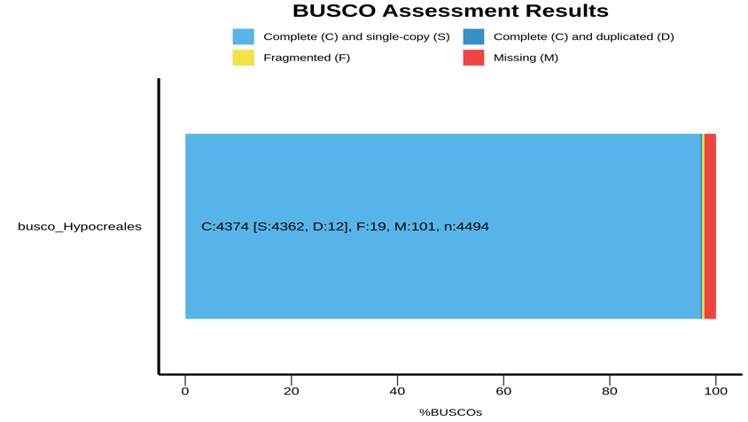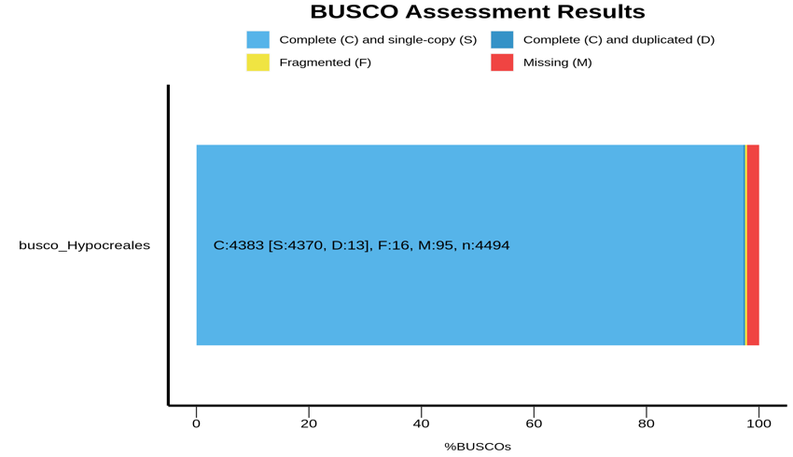

a

b

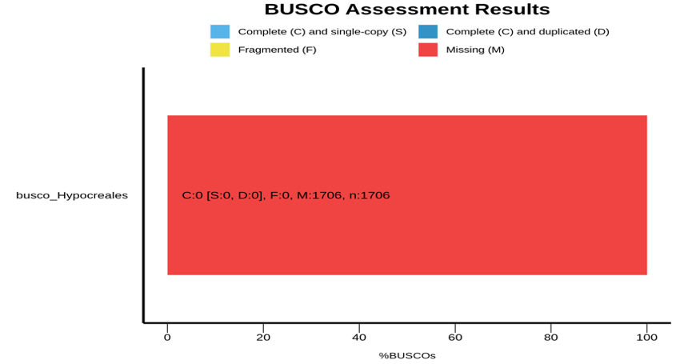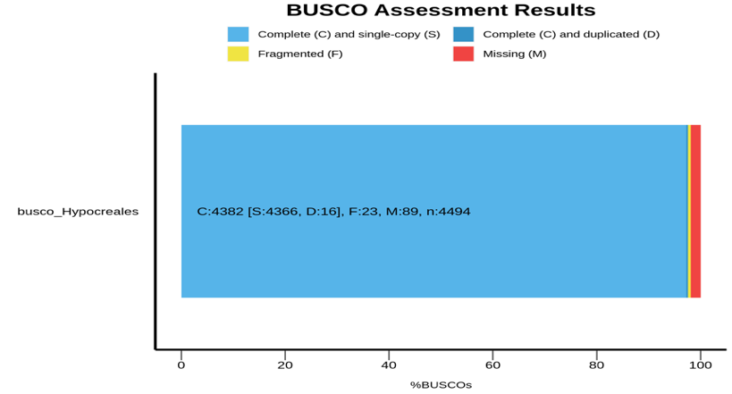

a

b

The *de novo* assemblies generated for S6 and S32 using reads which mapped to the ­*F. oxysporum* or ­*F. sacchari* references were assessed for taxonomic partitioning using BlobTools. The S6 *de novo* assembly built using *F. oxysporum* mapped reads contained hits from *Fusarium* species, including *F. fujikuroi* and *F. oxysporum,* no other genera were assigned to any contigs in this assembly, although 2,263 contigs had no hits (Figure 6). Similarly, the S32 *de novo* assembly built using *F. sacchari* mapped reads contained hits from *Fusarium* species andno other genera were assigned to any contigs in this assembly (Figure 7). The majority of contigs from the S32 *de novo* assembly built using *F. oxysporum* mapped reads had greatest sequence similarity to *Fusarium* species, but some contigs, particularly those with GC% above 60%, were assigned to *Stenotrophomonas maltophilia* (Figure 8).

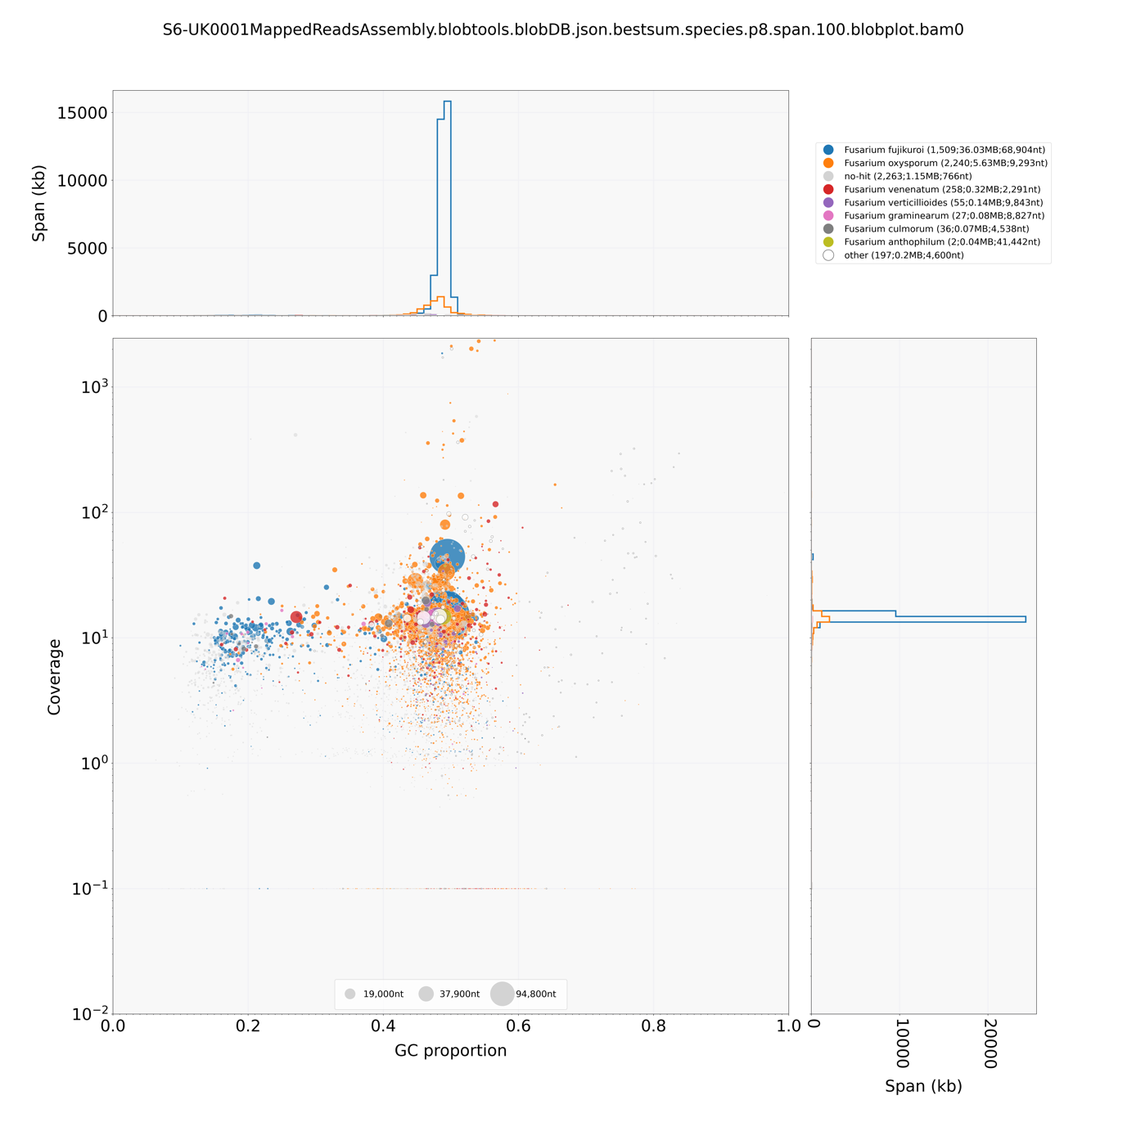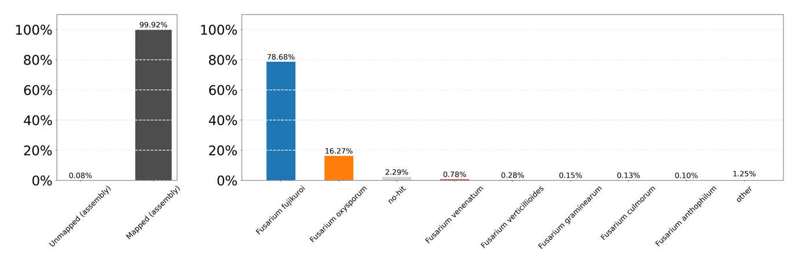

a

b

**Figure 6:** **BlobTools visualisations of S6 de novo assembly generated from the F. oxysporum mapped reads.** A)BlobPlot**,** sequences in the assembly are depicted as circles, with diameter scaled proportional to sequence length and coloured by taxonomic annotation (at the rank of species) based on BLASTN search of NCBI nt database. B) ReadCovPlot, mapped reads are shown by taxonomic group at the rank of species.

**Figure 7:** **BlobTools visualisations of S32 de novo assembly generated from the F. sacchari mapped reads.** A)BlobPlot**,** sequences in the assembly are depicted as circles, with diameter scaled proportional to sequence length and coloured by taxonomic annotation (at the rank of species) based on BLASTN search of NCBI nt database. B) ReadCovPlot, mapped reads are shown by taxonomic group at the rank of species.

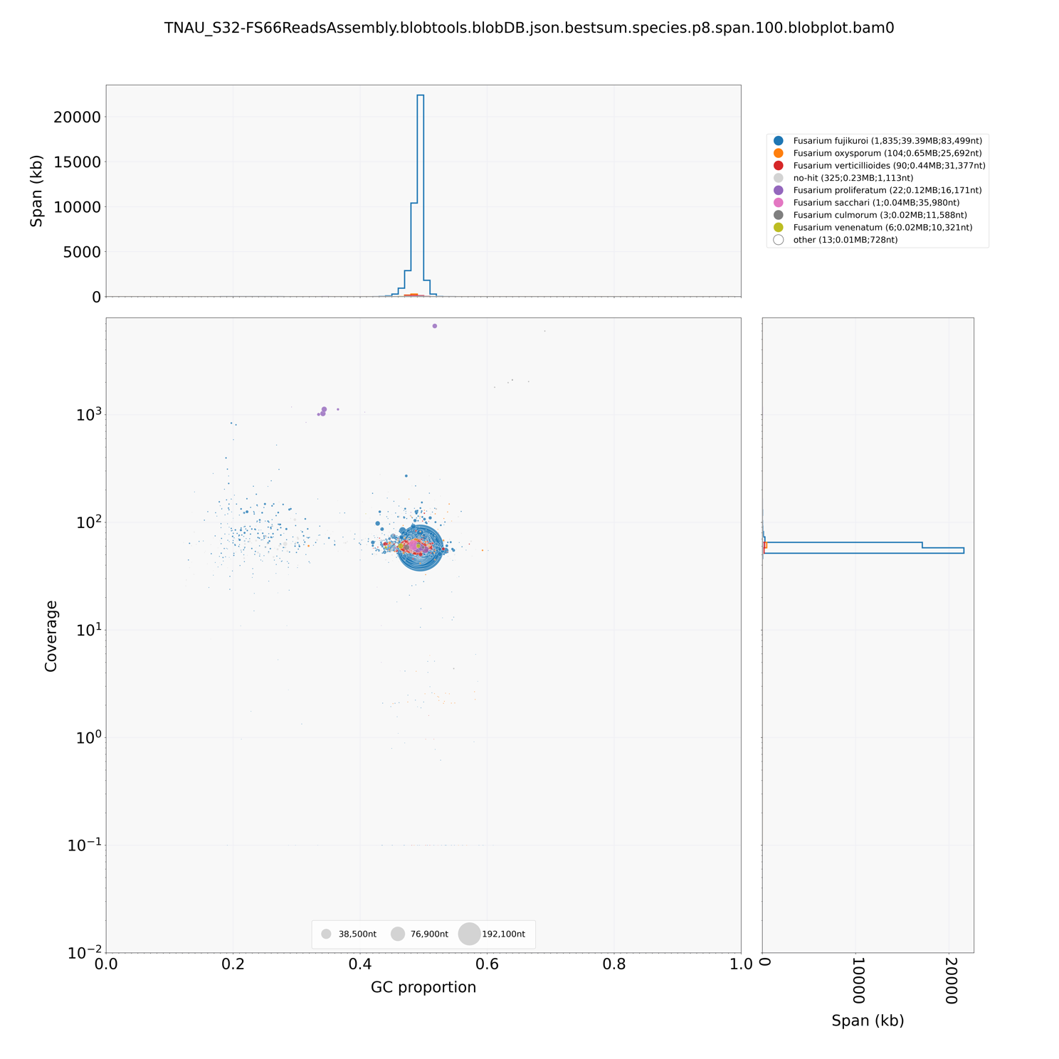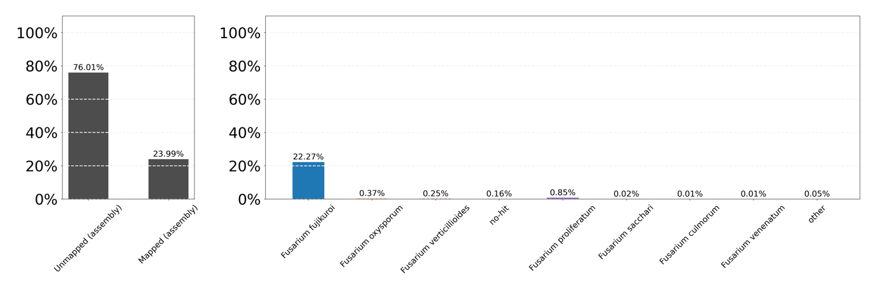

b

a

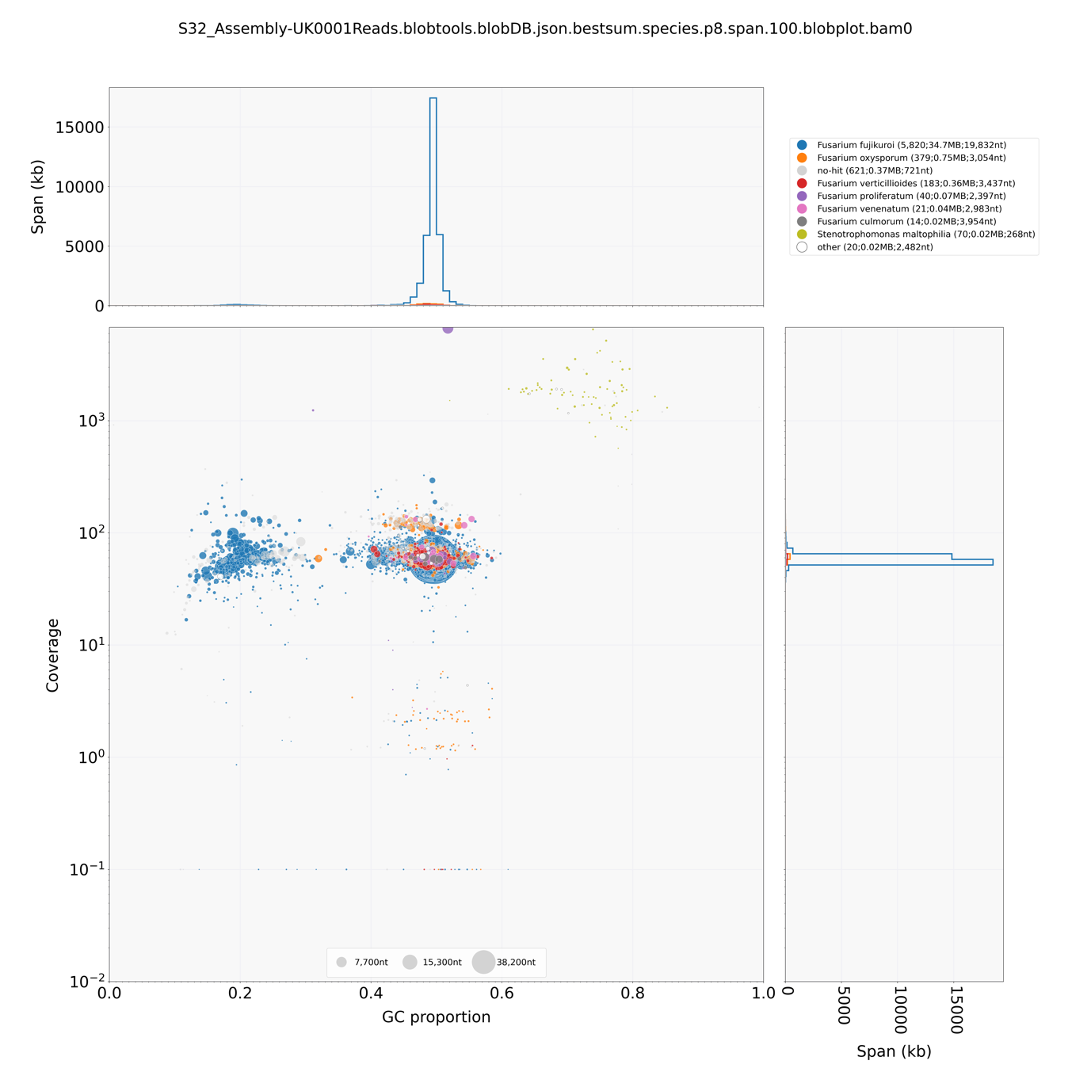

a

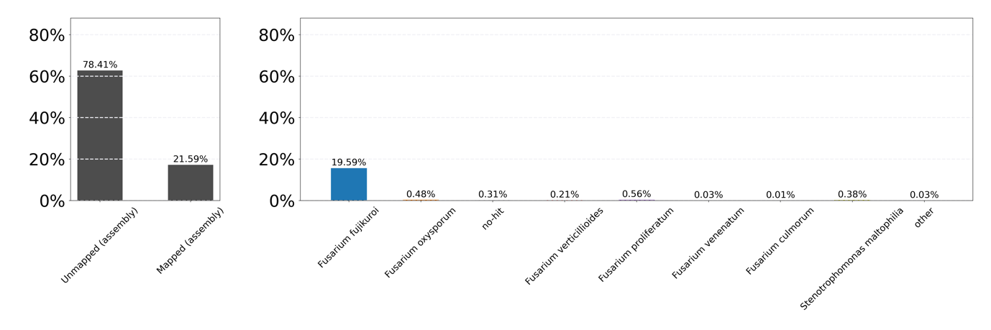

b

b

**Figure 8: BlobTools visualisations of S32 de novo assembly generated from the F. oxysporum mapped reads.** A)BlobPlot**,** sequences in the assembly are depicted as circles, with diameter scaled proportional to sequence length and coloured by taxonomic annotation (at the rank of species) based on BLASTN search of NCBI nt database. B) ReadCovPlot, mapped reads are shown by taxonomic group at the rank of species.

# Phylogenetic analysis

The common *Fusarium* genetic barcode *Tef-1𝛼* (Edel-Hermann and Lecomte, C., 2019) was used for phylogenetic analysis of the TNAU isolates alongside other *Fusarium* species*.* The SY-2 isolate *Tef*-1𝛼 sequence extracted for the phylogeny shared in June 2022 was also included in this phylogeny for reference. For the S16 isolate, the *Tef-1𝛼* sequence was extracted from the GC-trimmed *de novo* assembly. For the S6 and S32 isolates, the *Tef-1𝛼* sequence was extracted from the *de novo* assemblies generated using all raw reads as well as the ­*de novo* assemblies generated using the reference mapped reads.

Using a *Tef-1𝛼* database compiled from available reference sequences on the NCBI database, homologs of the *Tef*-1𝛼 barcode were identified in each TNAU isolate assembly through BLASTN (1e-6 cut-off). For each assembly, the locations of hits with greater than 70% identity and 90% coverage were recorded, and the sequence within this region extracted using Samtools (Version 1.15.1). Using the extracted *Tef-1𝛼* sequences the [Fusariod-ID MSLT database](https://www.fusarium.org/page/Homepage) and NCBI BLAST database were searched for similar sequences. For the S16 isolate, the Fusariod MSLT database best scoring hits were for *Fusarium fujikuroi* species complex, in which *F. sacchari* can be found (Table 3). Further, a search of the NCBI database revealed that the *Tef-1𝛼* sequence extracted from the S16 assembly best scoring hits were for *F. sacchari.* Searches for the S6 isolate extracted *Tef-1𝛼* sequences suggest this isolate belongs to the *F. oxysporum* species complex. Although there were matches for *F. oxysporum* f. sp. *cubense*  *Tef-1𝛼* sequences, these were not in the top 3 results from searches of both databases for the S6 isolate. This may be due to the quality of the S6 assembly. No matches were found for the S32 extracted *Tef-1𝛼* sequences in the Fusarioid-ID MSLT database, and hits against the NCBI GenBank database were for *F. fujikuroi* isolates*.*

The *Tef*-1𝛼 regions from each TNAU assembly and the in-house *Tef-1𝛼* database were also used to build a phylogenetic tree. *Tef*-1𝛼 sequences were concatenated into a single FASTA file. MAFFT (Katoh et al., 2019) was used to construct a multiple sequence alignment with the flag --adjustdirectionaccurately to ensure correct alignment. IQ-TREE (Version 2.2.0.3) was used to infer a maximum-likelihood phylogeny using the ultrafast bootstrap setting for 1000 bootstrap replicates (Nguyen et al., 2015) and was visualised using iTOL (Letunic and Bork, 2021).

The S16 isolate sits within the same clade as the SY-2 isolate and reference *F. sacchari* species based on the *Tef*-1𝛼 phylogeny which, taken together with the BOWTIE2 raw read mapping data, suggests these isolates may be strains of ­*F. sacchari* pathogenic towards banana(Figure 9). Based on the *Tef-1𝛼* phylogeny, the S32 isolate sits alongside the­ *F. sacchari* clade. The S6 isolate clusters within one the *F. oxysporum* f. sp. *cubense* clades which, alongside the higher mapping rate for to the *F. oxysporum* f. sp. *cubense* reference and Fusariod-DB and NCBI BLASTN results, suggests S6 is a *F. oxysporum* f. sp. *cubense* isolate (Figure 9). Interestingly, based on the *Tef-1𝛼* phylogeny, S6 clusters within a *F. oxysporum* f. sp. *cubense* race 1 clade, but collaborators at TNAU suggest that S6 is highly virulent against Cavendish banana varieties. Further work must be undertaken to improve the quality of the S6 genome assembly and determine which race of *F. oxysporum* f. sp. *cubense* the S6 isolate may be, as well as virulence tests comparing S6 to a Race 1 reference with high-quality genome sequence available, such as *F. oxysporum* f. sp. *cubense* R1 strain 160527 published by Asai., *et al.* (2019), to identify changes associated with enhanced virulence.

**Table 4: Best hits of extracted Tef-1𝛼** **sequences from the TNAU isolate de novo assemblies against the Fusariod-ID MSLT database and NCBI database.**

|  |  |  |  |  |  |  |
| --- | --- | --- | --- | --- | --- | --- |
| **TNAU**  **Isolate Assembly** | **Fusariod-ID MSLT database** | | | **NCBI database** | | |
| Match 1 | Match 2 | Match 3 | Hit 1 | Hit 2 | Hit 3 |
| S6 All reads | *F. oxysporum* species complex | *F. oxysporum* species complex | *F. oxysporum* species complex | *F. oxysporum* isolate 170 | *F. oxysporum* f. sp. *koae* | *F. oxysporum* f. sp. *dianthi* |
| S6  *F. oxysporum*  Reads | *F. oxysporum* species complex | *F. oxysporum* species complex | *F. oxysporum* species complex | *F. oxysporum* isolate 170 | *F. oxysporum* f. sp. *koae* | *F. oxysporum* f. sp. *dianthi* |
| S16 | *F. fujikuroi* species complex | *F. fujikuroi* species complex | *F. fujikuroi* species complex | *F. sacchari*  CBS:147.25 | *F. sacchari*  NRRL 66326 | *F. globosum* CBS:428.97 |
| S32 All reads | No Matches | No Matches | No Matches | *F. fujikuroi* I1.3 | *F. fujikuroi* IMI 58289 | *F. fujikuroi* Augusto2 |
| S32  *F. oxysporum*  Reads | No Matches | No Matches | No Matches | *F. fujikuroi* I1.3 | *F. fujikuroi* IMI 58289 | *F. fujikuroi* Augusto2 |
| S32  *F. sacchari*  Reads | No Matches | No Matches | No Matches | *F. fujikuroi* I1.3 | *F. fujikuroi* IMI 58289 | *F. fujikuroi* Augusto2 |



**Figure 9:** **Tef-1𝛼** **phylogeny of Fusarium isolates shows TNAU isolates S16, S32 and SY-2 sit within the F. sacchari clade.** The isolates from TNAU are shown in pink. The F. sacchari clade is shown in purple and the F. oxysporum f. sp. cubense clades in yellow. F. oxysporum f. sp. cubense Race 4 isolates are in blue, with Tropical Race 4 in light blue and Subtropical Race 4 in dark blue. F. oxysporum f. sp. cubense Race 1 isolates are shown in green. F. oxysporum f. sp. cubense isolates from Australia with race not yet determined are shown in grey. Percentages represent values from 1000 bootstrap replicates. The tree is rooted through Fusarium graminearum PH-1 Tef-1𝛼 sequence.

# Effector Profiling

*SIX* genes are the only known family of effectors so far confirmed in *F. oxysporum* (Armitage, et al., 2018). We searched for *SIX* genes from the F*. oxysporum* f. sp. *lycopersici* strain 007 reference set using TBLASTX (1e-6 cut-off) in the TNAU assemblies and *Fusarium* assemblies maintained in an in-house database. Sequences with >50% identity and >70% coverage were counted as present. No *SIX* genes were identified in any of the S32 assemblies. A *SIX2* homolog was identified in S16, clustering it alongside the SY-2 and *F. sacchari* assemblies (Figure 10). The S6 assemblies clustered separately and showed a reduced *SIX* gene content compared to most *F. oxysporum* assemblies, however, both clustered with *F. oxysporum* f. sp. *cubense* isolates.

**Figure 10: SIX gene distribution of TNAU assemblies shows S16 clusters with F. sacchari isolates and S6 clusters with F. oxysporum isolates.** SIX gene presence determined using TBLASTX (1e-6 cut-off, 50% identity and 70% coverage threshold).Presence is indicated by blue cells.

# Conclusions and Future Work

Several assemblies have been generated for the *Fusarium* Illumina PE data supplied by collaborators at TNAU. The raw read data supplied for isolates S6 and S32 contained some bacterial contamination, particularly from *Stenotrophomonas* species. Interestingly, although primarily a human pathogen, *S. maltophilia* has recently been reported as a plant pathogen of *Panax notoginseng,* causing root soft rot(Zheng, 2022). We are wondering whether the presence, and possible infection of *S. maltophilia,* increasesthe Cavendish banana’s susceptibility to the pathogenic *Fusarium* isolates collected and reported to be highly virulent by TNAU.

We have generated several assemblies for the S6 and S32 isolates to remove bacterial contamination and help classification. Based on our analysis, S6 appears to be a *F*. *oxysporum* f. sp. *cubense* race 1 isolate. The raw reads from S6 are therefore being mapped to the *F. oxysporum* f. sp. *cubense* race 1 strain 160527 assembly published by Asai., *et al.* (2019) in order to generate an assembly for the S6 isolate.

The S16 and S32 isolates appear to be from the *F. fujikuroi* species complex. Annotation of the S16 and S32 assembly is currently being repeated using MAKER2 and SNAP, with the *F. sacchari* proteome as reference. Notably, a novel species of *Fusarium* (*F. mindanaoense*) affecting Cavendish banana within the *F. fujikouri* species complex has been recently reported in the Philippines by Nozawa, *et al.,* (2023). The authors suggest that their novel species is a sister lineage of *F. sacchari* but has also acquired *SIX6,* though they have not confirmed the *SIX6* homolog identified is involved in virulence in their novel species and *SIX6* was not identified in our assemblies using out BLAST strategy. I am currently trying to source the sequences the authors used for their phylogenetic analysis to compare against the isolates shared by TNAU, and an repeating the SIX gene blast search using the same approach as Nozawa, *et al.,* (2023), to see if *SIX6* is identified. Further work is essential if we are to determine if any of the TNAU isolates belong to the novel species proposed by Nozawa, *et al.,* (2023).

# References

Armitage, A.D., Taylor, A., Sobczyk, M.K., Baxter, L., Greenfield, B.P., Bates, H.J., Wilson, F., Jackson, A.C., Ott, S., Harrison, R.J. and Clarkson, J.P., 2018. Characterisation of pathogen-specific regions and novel effector candidates in Fusarium oxysporum f. sp. cepae. *Scientific reports*, *8*(1), pp.1-15.

Asai, S., Ayukawa, Y., Gan, P., Masuda, S., Komatsu, K., Shirasu, K. and Arie, T., 2019. High-quality draft genome sequence of Fusarium oxysporum f. sp. cubense strain 160527, a causal agent of Panama disease. *Microbiology Resource Announcements*, *8*(29), pp.e00654-19.

Cui, Y., Wu, B., Peng, A., Song, X. and Chen, X., 2021. The Genome of Banana Leaf Blight Pathogen Fusarium sacchari str. FS66 Harbors Widespread Gene Transfer From Fusarium oxysporum. *Frontiers in Plant Science*, *12*, p.629859.

Edel-Hermann, V. and Lecomte, C., 2019. Current status of Fusarium oxysporum formae speciales and races. *Phytopathology*, *109*(4), pp.512-530.

Gurevich, A., Saveliev, V., Vyahhi, N. and Tesler, G., 2013. QUAST: quality assessment tool for genome assemblies. *Bioinformatics*, *29*(8), pp.1072-1075.

Katoh, K., Rozewicki, J., Yamada, K.D., 2019. MAFFT online service: multiple sequence alignment, interactive sequence choice and visualization. Brief. Bioinform. 20, 1160–1166. <https://doi.org/10.1093/bib/bbx108>

Laetsch, D.R. and Blaxter, M.L., 2017. BlobTools: Interrogation of genome assemblies. *F1000Research*, *6*(1287), p.1287.

Letunic, I., Bork, P., 2021. Interactive Tree Of Life (iTOL) v5: an online tool for phylogenetic tree display and annotation. Nucleic Acids Res. 49, W293–W296. <https://doi.org/10.1093/nar/gkab301>

Manni, M., Berkeley, M.R., Seppey, M., Simão, F.A. and Zdobnov, E.M., 2021. BUSCO update: novel and streamlined workflows along with broader and deeper phylogenetic coverage for scoring of eukaryotic, prokaryotic, and viral genomes. *Molecular biology and evolution*, *38*(10), pp.4647-4654.

Nguyen, L.-T., Schmidt, H.A., von Haeseler, A., Minh, B.Q., 2015. IQ-TREE: A Fast and Effective Stochastic Algorithm for Estimating Maximum-Likelihood Phylogenies. Mol. Biol. Evol. 32, 268–274. <https://doi.org/10.1093/molbev/msu300>

Nozawa, S., Seto, Y., Takata, Y., Narreto, L.A., Valle, R.R., Okui, K., Taida, S., Alvindia, D.G., Reyes, R.G. and Watanabe, K., 2023. Fusarium mindanaoense sp. nov., a New Fusarium Wilt Pathogen of Cavendish Banana from the Philippines Belonging to the F. fujikuroi Species Complex. *Journal of Fungi*, *9*(4), p.443.

Okonechnikov, K., Conesa, A. and García-Alcalde, F., 2016. Qualimap 2: advanced multi-sample quality control for high-throughput sequencing data. *Bioinformatics*, *32*(2), pp.292-294.

Warmington, R.J., Kay, W., Jeffries, A., O’Neill, P., Farbos, A., Moore, K., Bebber, D.P. and Studholme, D.J., 2019. High-quality draft genome sequence of the causal agent of the current Panama disease epidemic. *Microbiology Resource Announcements*, *8*(36), pp.e00904-19.

Zheng, K., Su, X., Xue, Z., Zhang, L., Chen, Y., Wu, K., Li, T., Zhang, Z. and Zhao, Z., 2022. First report of Stenotrophomonas maltophilia causing root soft rot of Sanqi (Panax notoginseng) in China. *Plant Disease*, *106*(2), p.755.

1. Includes all raw reads originally supplied.